

NAME/ID : ABDELKAREEM YOUSEF MAMDOH SOUBAR/19110022
SUBJECT : IOT
ASSIGNMENT INCLUDES : Task 1
DEAD LINE : 22/11/2022

• Product name
August Home AUG-AB02-M02-S02 Silver August Doorbell Cam Pro

• Description
its a Doorbell and a Cam in the same item it can pair with your device and at any time and place lets you know if any one came rang or if there is a movement in front if your door it stays active 24h
• use case
this device is used at door step beside/ on the door so it can be used as a ring bell and it has a camera to keep recording 24h.
This devices is usually need in home that suspect that thing get stolen from their door step or think there is a suspsus activity that happens in front of there house
• sector
Home security
• list of functions that are offered
Always home
Real time alerts, HD video and two way audio makes it easy to answer your door as if you were home.

Get the whole story
HindSight constantly monitors your doorway and will capture the moments leading up to a motion alert.

Never miss a moment
Free 24 hour video storage with Basic Recording Subscription included.
Easy Installation
really simple to install

• Benefits
you can answer your door from anywhere from the phone application and alert you if anyone rang the door bell plus it records 24h with a motion sensor

• Vendors
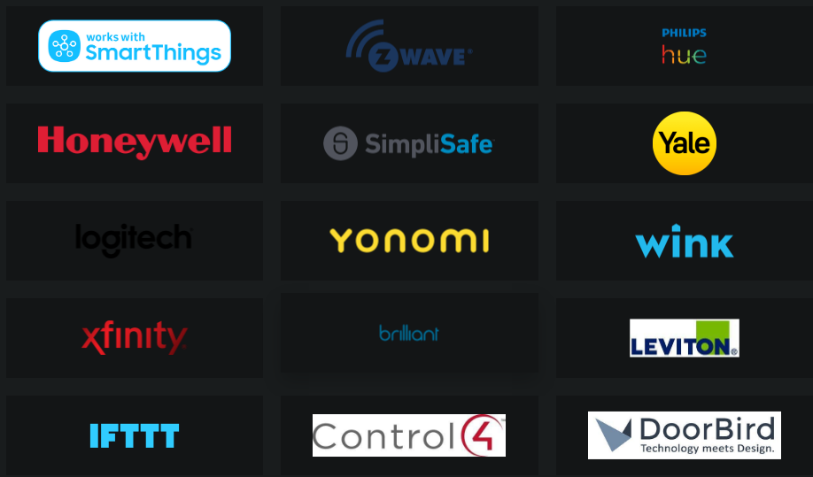
References
august.com. (n.d.). August Home | Smart Door Locks and Accessories. [online] Available at: https://august.com/.

‌

